 

**SUMMER INTERNSHIP**

**PROJECT ON GENERAL ERP CONCEPT**

**ROHAN RAWAT**

**Bachelor of Technology (DATA SCIENCE)**

**(Roll No - 2100301540062)**

**(SESSION: 2021 – 2025)**

**INDERPRASTHA ENGINEERING COLLEGE**

**GHAZIABAD, UTTAR PRADESH**

**AFFILIATED TO DR. A.P.J. ABDUL KALAM TECHNICAL UNIVERSITY**

**LUCKNOW, UTTAR PRADESH**

**INTERNSHIP PROJECT DURATION**

**(22 MAY 2025 TO 20 JULY 2025)**



**TABLE OF CONTENTS**

|  |  |  |
| --- | --- | --- |
| **S.NO** | **TITLE** | **PAGE NO.** |
| **1.** | Brief about Standard Concept of Industry.  1.1 Introduction about Industries / Organization / Enterprises.  1.2 Key aspects of the Standard Concept of Industry.  1.3 Classification of Basis type, Size, Vertical, Category wise, Ownership-wise. | CHAPTER 1  03 – 06 |
| **2.** | Group of Industries Manage Different Verticals, Operations, and Locations.  2.1 Elaboration about Industrial Management Team & Operation System.  2.2 Hierarchy & Role of Management Team in Industries Operations. | CHAPTER 2  07 - 13 |
| **3.** | Concept of industry and management.  3.1 INDUSTRY  3.2 MANAGEMENT | CHAPTER 3  14 – 15 |
| **4.** | Role of management  4.1 Key Roles and Responsibilities of Management in ERP Implementation  4.2 Major reason of ERP implementation failure. | CHAPTER 4  16 – 21 |
| **5.** | GENERAL CONCEPTS OF ERP  5.1 Benefit of using an ERP system  5.2 Key module of ERP  5.3 Describe E,R,P In Detail | CHAPTER 5  22 – 27 |
| **6.** | What do you understand by ERP  6.1 What is an ERP?  6.2 ERP fundamentals. | CHAPTER 6  28 – 29 |
| **7.** | Why INDUSTRY Require ERP  7.1 DIFFERENT MODULE OF ERP WITH DIAGRAM  7.2 ADVANTAGES AND DISADVANTAGES OF ERP | CHAPTER 7  30 – 35 |
| **8.** | Step of ERP Implementation Process  8.1 Key Steps in the ERP Implementation Process | CHAPTER 8  36 - 37 |
| **9.** | Process flow of material management in ERP  9.1 Material Management Process Flow in ERP  9.2 Simplified Flow Diagram  9.3 Key ERP Modules Involved | CHAPTER 9  38 - 40 |
| **10.** | Main Element Used to Implementation of ERP   * Master data * Transaction * Reports | CHAPTER 10  41 – 45 |
| **11.** | KNOWLEDGE AND EXPERIENCE GAIN ACHIEVEMENT FROM PROJECT  11.1 Technical Knowledge  11.2Business Process Understanding  11.3 Teamwork and Communication  11.4 Personal Achievements | CHAPTER 11  46 - 47 |

**Introduction about Industries / Organization / Enterprises**

* **Industries**

An industry refers to a group of companies or businesses that produce similar or related products or services. Industries are typically classified based on their primary economic activity, such as manufacturing, mining, construction, agriculture, or services. For example, the automobile industry involves companies engaged in the design, production, marketing, and sale of motor vehicles.

* **Organizations**

An organization is a structured group of people who work together to achieve specific goals. It can be a business firm, government body, non-profit institution, or any other entity formed for a particular purpose. Organizations operate with a defined hierarchy, roles, policies, and processes, ensuring efficient resource use and goal attainment. They can vary in size, scope, and function from small local NGOs to global corporations like Google or the United Nations.

* **Enterprises**

An enterprise generally refers to a business venture or initiative, often associated with entrepreneurial activities. It can be small (like a startup) or large (like a multinational corporation). Enterprises focus on innovation, value creation, and market competitiveness. They can be private, public, or joint ventures.

**Standard Concept Of Industry:**

**The standard concept of industry refers to the systematic classification and understanding of industries based on their function, structure, scale, supply chain position, and classification codes. It helps in organizing economic activities, policy planning, business analysis, and investment decisions.**

**Key aspects of the standard concept of industry:**

1. **Group of Businesses:**

An industry is a collection of companies that operate within a specific economic sector, like manufacturing or service provision.

1. **Shared Activities:**

These businesses engage in similar or related activities, such as producing automobiles, providing financial services, or extracting raw materials.

1. **Classification System:**

Industries are categorized using standardized classification systems, like the Standard Industrial Classification (SIC), which helps in analysis and comparison.

1. **Economic Sectors:**

Industries form the building blocks of larger economic sectors, which are broad categories of economic activity.

1. **Evolution and Change:**

Industries can evolve over time, with new industries emerging, existing ones changing, and some even disappearing.

**classification:**

1. **Type-wise (Based on Economic Function):**

* **Primary Industries:**

These involve the extraction and harvesting of natural resources, like agriculture, mining, fishing, and forestry.

* **Secondary Industries:**

These are manufacturing and processing industries that convert raw materials into finished goods, such as car manufacturing, electronics, or clothing.

* **Tertiary Industries:**

Also known as the service sector, these provide services to businesses and consumers, including retail, entertainment, financial services, and hospitality.

* **Quaternary Industries:**

These focus on knowledge-based activities like research, technology, education, and information services.

* **Quinary Industries:**

High-level decision making and policy like Government, CEOs, Nonprofits.

1. **Size-wise (Based on Investment and Employment):**

* **Micro-enterprises:**

Typically have limited investment and small numbers of employees. < 10 employees; low revenue like Local bakery, Freelancer.

* **Small-scale industries:**

 Characterized by a moderate level of investment and a smaller workforce than medium or large-scale industries. < 50 employees; moderate revenue like Boutique firm, Small factory.

* **Medium- scale industries:**

Involve a significant investment and employ a larger workforce than small-scale industries. 50–250 employees like Regional manufacturers.

* **Large-scale industries:**

Require substantial investment and employ a large number of workers. > 250 employees like Multinational corporations, Conglomerates.

1. **Vertical-wise (Based on Supply Chain):**

* **Upstream Industries:**

These are involved in the extraction and production of raw materials, such as mining, oil and gas extraction, or agriculture.

Initial production phases.

* **Midstream Industries:**

These focus on processing raw materials into intermediate products, like steel mills, or petrochemical plants. Processing or transportation.

* **Downstream Industries:**

These are involved in the manufacturing and distribution of finished goods, such as car manufacturers, clothing retailers, or consumer electronics companies. Final product & delivery to customer.

1. **Product Category-wise (Based on Product/Service):**

* **Consumer Goods Industries:**

Produce goods for direct consumption, like food, clothing, or household appliances.

* **Capital Goods Industries:**

Produce goods used in the production of other goods, like machinery, tools, or equipment.

* **Intermediate Goods:**

Products used in the production of other goods but are not final products (e.g., raw materials, components).

1. **Ownership-wise:**

* **Public Sector:**

Owned and operated by the government.

* **Private Sector:**

Owned and operated by individuals or private companies.

* **Joint Sector:**

Owned and operated jointly by the public and private sectors.

* **Cooperative Sector:**

Owned and operated by a cooperative of producers or suppliers.

**Group of Industries Manage Different Verticals, Operations, and Locations:**

A group of industries such as a diversified business group often operates multiple verticals (business segments), across different locations and branches, with varied types of operations (manufacturing, sales, logistics, finance, hr). Managing this complexity efficiently requires a centralized, integrated solution and that's where enterprise resource planning systems play a crucial role.

**1.Understanding the Complexity of Multi-Vertical, Multi-Location Operations.**

* Manufacturing (Vertical A)
* Retail (Vertical B)
* Logistics (Vertical C)  
  Each vertical may have:
* Separate processes (e.g., production planning vs. retail Point of sales).
* Different Key Performance Indicators (KPIs).
* Diverse compliance requirements.

**2. Role of ERP in Managing the Group-wide Operations**

ERP acts as a central nervous system that connects all departments, business units, and geographies into a single, unified platform.

**3. Multi-Location and Branch Management**

ERP enables:

* Centralized Database: A single source of truth for all branches and departments.
* Location-Based Access: Branch-specific dashboards for local teams; global view for Head quater.
* Inter-branch Transactions: Auto handling of intercompany transfers, stock movement, and billing.
* Localization Support: Regional tax rules, local languages, and time zones.
  1. **Managing Different Verticals (Business Units) Within the Same ERP.**
* Independent process workflows
* Customized dashboards and reporting
* Internal transfer pricing and inter-vertical coordination.

1. **Real-Time Monitoring & Decision Making.**

ERP provides:

* Dashboards & Key Performance Indicators across all verticals and branches.
* Alerts for low stock, delayed orders, or compliance gaps.
* Scenario analysis for better forecasting and resource planning.
* Role-based access ensuring data security across different levels of the organization.

1. **Benefits of ERP for Multi-Industry Groups.**

| Benefit | Description |
| --- | --- |
| Operational Efficiency | Streamlined workflows, reduced duplication, and real-time information flow |
| Better Collaboration | Seamless communication across departments, branches, and units |
| Data-Driven Decisions | Unified reporting across verticals aids strategic planning |
| Compliance & Risk Management | In-built controls for tax, audit, and legal compliance |
| Scalability | Easily add new branches or verticals as business expands |

**Concept of Industrial Management**

Industrial Management refers to the process of planning, organizing, directing, and controlling industrial operations to achieve organizational goals efficiently. It involves managing people, materials, machines, methods, money, and markets also known as the 6 m’s of industrial management.

* 1. **Structure of Industrial Management Team**
     1. **Top-Level Management**

Responsible for strategic decision-making, vision setting, and long-term goals.

| **Role** | **Key Responsibilities** |
| --- | --- |
| Chairman / Managing Director / CEO | - Define vision & mission- Strategic decisions- Represent company externally |
| Board of Directors | - Policy formation- Approving budgets- Governance & compliance |
|  |  |

* + 1. **Middle-Level Management**

Acts as a bridge between top management and operational staff. Translates strategic goals into actionable plans.

| **Role** | **Key Responsibilities** |
| --- | --- |
| General Managers / Plant Heads / Department Heads | - Execute policies- Departmental coordination- Staff supervision |
| Production, HR, Finance, Marketing Managers | - Planning department operations- Managing department teams- Reporting to top management |

* + 1. **Operational / Lower-Level Management**

Directly oversees daily activities on the business operations.

| **Role** | **Key Responsibilities** |
| --- | --- |
| Supervisors / Line Managers / Foremen | - Assign tasks- Quality control- Monitor employee performance |
| Team Leaders / Shift In-charge | - Daily task execution- Equipment handling- Ensuring safety standards |

* 1. **Functional Areas of Industrial Operation System**

An industrial operation system is a network of functional areas working together to produce goods or deliver services efficiently.

1. **Production Management**

* Ensures raw materials are converted into finished goods efficiently.
* Controls machines, tools, workers, processes.

**B. Materials & Inventory Management**

* Manages procurement, storage, and usage of raw materials and parts.
* Uses **Material Requirement Planning (MRP)** & **Inventory Control Techniques** like Economic Order Quantity, Just-In-Time.
  + 1. **Quality Control & Assurance**
* Ensures the output meets predefined quality standards.
* Involves inspection, testing, process improvement.
  + 1. **Human Resource Management (HRM)**
* Manages workforce hiring, training, performance, safety, and compliance.
* Also includes labor law compliance and industrial relations.

**E. Finance & Cost Management**

* Budgeting, investment planning, cost control, pricing strategies.
* Prepares cost sheets, profit & loss accounts, and ROI analysis.

**F. Marketing & Sales**

* Manages branding, product promotion, market analysis, customer relations.
* Sales planning and distribution channel management.

**G. Information Technology (IT) & ERP Systems**

* Supports operations using integrated ERP software for:
  + Inventory tracking
  + Order processing
  + Finance and HR modules
  + Real-time data for decision-making
  1. **Industrial Operational Workflow**

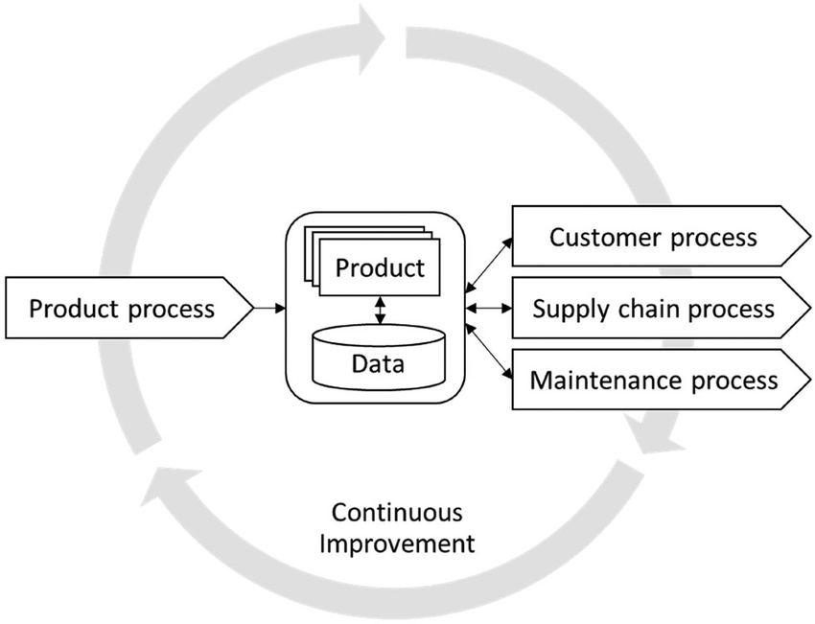

**Hierarchy & Role of Management Team in Industries Operations**

In industrial operations, the management team is structured in a hierarchical manner to effectively oversee and direct various aspects of the business. This hierarchy typically includes top-level, middle-level, and first-line management, each with distinct roles and responsibilities. Top-level management focuses on strategic decision-making, middle-level managers implement those strategies, and first-line managers oversee day-to-day operations.

**Levels of Management and their Roles:**

**1. Top-Level Management:**

* **Responsibilities:**Setting the overall direction of the organization, making strategic decisions, allocating resources, and ensuring the company's long-term success.
* **Key Roles:**CEO, CFO, COO, Board of Directors, and other high-level executives.
* **Example:**The CEO makes decisions about market expansion, while the CFO oversees financial planning and reporting.

**2. Middle-Level Management:**

* **Responsibilities:**Translating strategic goals into actionable plans, coordinating activities between different departments, and managing resources within their areas of responsibility.
* **Key Roles:**General managers, regional managers, department managers (e.g., marketing manager, HR manager)**.**
* **Example:**A marketing manager might develop a marketing strategy based on the CEO's directives and manage a team to execute that strategy.

**3. First-Line Management:**

* **Responsibilities:**Supervising daily operations, providing guidance and support to front-line employees, and ensuring tasks are completed efficiently.
* **Key Roles:**Supervisors, team leaders, shift managers.
* **Example:**A supervisor might oversee a team of production workers, ensuring they adhere to safety procedures and meet production quotas.

**Key Functions of Management:**

Regardless of the management level, all managers engage in the four key functions of management: planning, organizing, leading, and controlling.

1. **Planning:**

Setting goals and objectives, developing strategies, and allocating resources.

1. **Organizing:**

Structuring the organization, defining roles and responsibilities, and coordinating activities.

1. **Leading:**

Motivating and guiding employees, communicating effectively, and building a positive work environment.

1. **Controlling:**

Monitoring performance, measuring results against goals, and taking corrective action when needed.

**Hierarchical structure of Management Team**

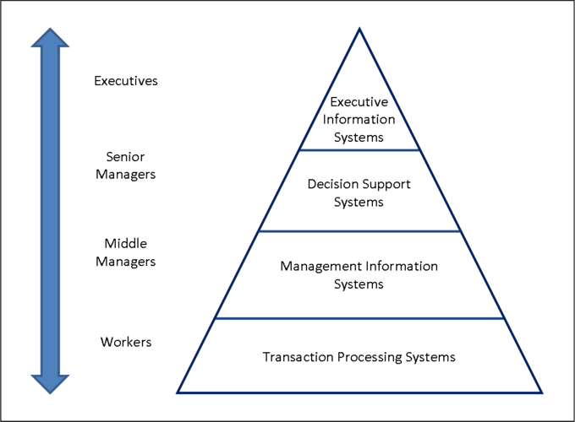

**CONCEPT OF INDUSTRY AND MANAGEMENT**

The standard concept of industry and management refers to a structured framework that defines how industries operate and how management principles are applied to organize, control, and grow these industries efficiently.

1. **INDUSTRY:**

* **Definition:**A group of enterprises or organizations that produce a similar kind of goods or services.
* **Examples:**

Manufacturing (automobiles, electronics), service industries (healthcare, hospitality), resource extraction (mining, oil), and construction.

* **Economic Impact:**

Industries play a crucial role in the economy, contributing to employment, production, and overall economic activity.

1. **Management:**

* **Definition:**

The process of bringing together resources (human, financial, physical, information, technological) and directing them towards achieving organizational goals.

* **Functions:**

Management encompasses planning, organizing, leading, controlling, and coordinating activities to ensure efficient resource utilization and goal attainment.

* **Key Objectives:**

Providing customer satisfaction, delivering high-quality goods or services, achieving efficient resource utilization, and managing costs and performance.

* **Scope:**

Management principles and practices are applied across various industry sectors, from manufacturing and construction to services and technology.

* **Evolution:**

Management approaches have evolved over time, from classical to neoclassical to systems-oriented perspectives, reflecting a growing understanding of organizational dynamics and the importance of integration.

**Role of management**

**Management plays a crucial role in the successful implementation of an ERP system, particularly in areas like providing leadership, securing resources, and fostering change management. A strong management team can ensure that the ERP project aligns with business objectives, is adequately funded, and receives the necessary support from all levels of the organization.**

**Key Roles and Responsibilities of Management in ERP Implementation:**

* 1. **Leadership and Strategic Alignment:**
* **Executive Sponsorship:**

Senior management must be involved as a champion and sponsor of the project to ensure buy-in from all levels of the organization and provide the necessary resources and support.

* **Resource Allocation and Support:**

Management needs to secure the necessary resources, including financial support, personnel, and IT infrastructure, to support the project. They also need to provide the project team with the necessary authority to make decisions and implement changes.

* **Change Management:**

ERP implementations often involve significant changes to business processes, workflows, and organizational structure. Management must actively facilitate change management, ensuring that employees are prepared for the transition and understand the benefits of the new system. This includes addressing employee concerns, providing training, and communicating the value of the new system.

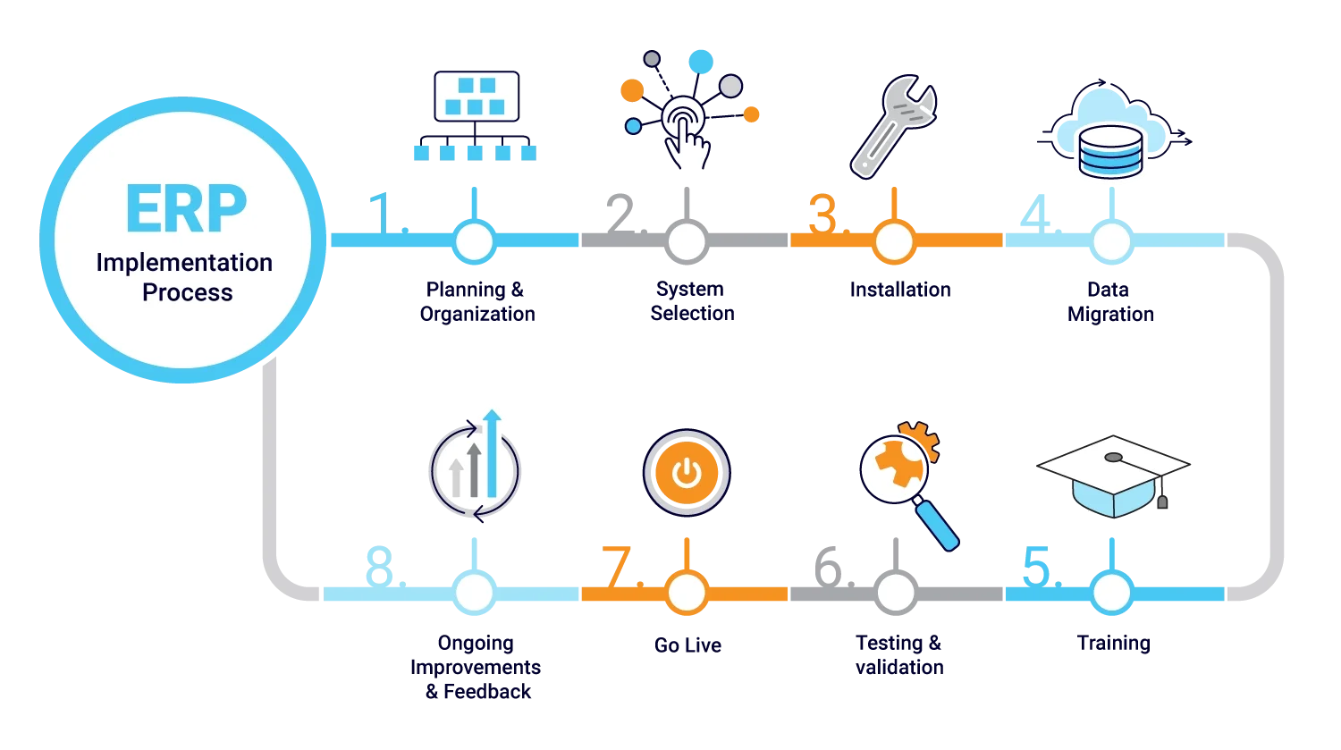

* **Collaboration and Communication:**

Management should foster a collaborative environment, encouraging communication and knowledge sharing among different departments and stakeholders. They should also ensure that the project team is kept informed about progress, challenges, and any necessary changes.

* **Monitoring and Evaluation:**

Management must track the progress of the implementation, measure the success of the project, and identify areas for improvement. They should also evaluate the long-term benefits of the ERP system and ensure that it continues to meet the organization's needs.

* **Executive Sponsorship:**

An executive sponsor at the top level can help champion the project, secure necessary approvals, and ensure that the implementation receives the attention and resources it needs. They can also help to overcome resistance to change and build support for the new system.

* **Evaluation & Continuous Improvement:**

Post-implementation, evaluate success against KPIs. Promote optimization: fine-tuning modules, enhancing reporting, automating workflows. Ensure the ERP system evolves with business needs.

**Importance of Management Hierarchy in Industry Operations**

* Clear Accountability: Defines “who is responsible for what”.
* Effective Supervision: Managers oversee specific operations and resources.
* Better Coordination: Departments collaborate based on a defined chain of command.
* Efficient Decision-Making: Authority levels are pre-defined for faster action.
* Performance Monitoring: Each level tracks and improves results in real-time.
* Scalability: Easy to replicate structure across new units or branches.

**Major reason of ERP implementation failure**

A major reason for ERP implementation failure is a lack of clear objectives and a well-defined strategy. This includes not having a clear understanding of business needs, poorly defined system requirements, insufficient training, inadequate change management, and unrealistic project timelines. Without a solid plan and clear goals, organizations may struggle to align the ERP system with their business processes and may face resistance from employees who are not adequately prepared for the change.

* 1. **Lack of Clear Objectives and Strategy:**
* **Undefined Goals:**

Organizations fail to establish specific, measurable, achievable, relevant, and time-bound (SMART) goals for the ERP implementation.

* **Unclear Requirements:**

Without a thorough understanding of their needs, companies struggle to align the ERP system with their business processes.

* **Misaligned Expectations:**

A lack of clarity on what the ERP system is expected to achieve leads to unrealistic expectations and potential disappointment.

* 1. **Insufficient Training and Change Management:**
* **Lack of Training:**

Employees may not be adequately prepared to use the new ERP system, leading to frustration and a reluctance to adopt it.

* **Poor Change Management:**

Organizations fail to effectively communicate the changes and manage employee resistance, leading to a decline in engagement and confusion.

* 1. **Insufficient Planning and Resources:**
* **Underestimation of Resources:**

Companies often underestimate the resources (time, budget, personnel) required for a successful ERP implementation.

* **Poor Project Management:**

Lack of effective project management can lead to delays, cost overruns, and scope creep.

* **Insufficient Testing:**

Inadequate testing before deployment can result in major issues once the system is launched.

* 1. **Poor Data Management:**
* **Poor Data Quality:**

Inaccurate or incomplete data can lead to unreliable reports and decision-making.

* **Data Migration Issues:**

Challenges during data migration can disrupt operations and lead to delays.

* 1. **Lack of Leadership Commitment and Support:**
* **Insufficient Executive Buy-in:**

Lack of support from leadership can hinder the project's progress and create resistance from employees.

* **Disinterested Leadership:**

Leadership may not be fully engaged in the project, leading to a lack of accountability and a failure to address critical issues.

**By addressing these factors, organizations can significantly increase their chances of successfully implementing an ERP system and realizing its full potential.**

**GENERAL CONCEPTS OF ERP**

**ERP** - An Enterprise Resource Planning (ERP) system is a software solution that integrates various business processes across different departments, creating a unified view of the organization's operations. It essentially acts as a central database and platform for managing key functions like finance, human resources, supply chain, manufacturing, and sales.

Key concepts:

1. **Intergration**:

ERP systems connect different functional areas within a company, eliminating data silos and promoting seamless information flow.

1. **Centralized Database:**

All business data is stored in a single, shared database, accessible by various departments.

1. **Business Process Management:**

ERP supports and automates key business processes, such as order-to-cash and procurement-to-pay, improving efficiency.

1. **Real-time Visibility:**

ERP provides real-time insights into operational and financial performance, enabling better decision-making.

1. **Modular Design:**

ERP systems are often modular, allowing businesses to choose and implement specific modules based on their needs.

1. **Scalability:**

ERP systems can scale to accommodate the growth and evolving needs of an organization.

1. **Single Source of Truth:**

ERP provides a single, accurate source of information for all business data, reducing data duplication and inconsistencies.

**Benefits of using an ERP system:**

1. **Improved Efficiency:**

By automating processes and integrating data, ERP systems can streamline operations and reduce manual efforts.

1. **Enhanced Decision-Making:**

Real-time data and reporting capabilities empower managers to make informed decisions.

1. **Reduced Costs:**

By optimizing resource utilization and eliminating redundancy, ERP can contribute to cost savings.

1. **Improved Data Accuracy:**

A single, centralized database ensures data accuracy and consistency, reducing errors and improving reliability.

1. **Enhanced Collaboration:**

ERP facilitates communication and collaboration across departments, breaking down silos and improving team performance.

1. **Better Customer Service:**

ERP provides a comprehensive view of customer data, enabling businesses to personalize interactions and improve customer satisfaction.

1. **Increased Agility:**

ERP systems can adapt to changing market conditions and business requirements more quickly, providing a competitive advantage.

**Key Modules of ERP**

1. **Finance & Accounting:**

General ledger, accounts payable/receivable, financial reporting

1. **Human Resources (HR):**

Payroll, employee records, recruitment, time tracking

1. **Sales & CRM (Customer Relationship Management):**

Quotes, orders, invoices, customer data, sales tracking

1. **Procurement:**

Supplier management, purchase orders, contract management

1. **Inventory & Warehouse Management:**

Production planning, BOM (Bill of Materials), shop floor control

1. **Project Management:**

Task tracking, resource allocation, budgeting

1. **Manufacturing:**

Production planning, BOM (Bill of Materials), shop floor control

1. **Supply Chain Management (SCM):**

Logistics, distribution, demand planning

**Core Idea of ERP**

**"One system, one source of truth"**

ERP centralizes data from various departments—finance, HR, sales, supply chain, inventory, etc.—so that everyone works with real-time, consistent data.

**Describe E,R,P In Detail:**

**To provide a detailed explanation of E, R, and P, we first need context, as these abbreviations can have multiple meanings depending on the domain (e.g., business, engineering, economics, ERP systems, etc.).**

**However, in the industrial/business context, the terms E, R, and P are most commonly associated with ERP:**

1. **E — Enterprise:**

**Meaning:**

Refers to the entire organization or business, not just a single department or function.

**Key Points:**

* Encompasses all departments: finance, HR, manufacturing, supply chain, marketing, etc.
* Focuses on cross-functional coordination.
* Goal: Holistic, unified business management.

**Examples:**

* A large manufacturing company integrating its procurement, production, and sales departments.
* A hospital linking patient care, billing, and HR systems.

1. **R — Resource:**

**Meaning:**

Represents all the assets and inputs that a business uses to operate and deliver value.

**Includes:**

* Human resources (employees, skills, payroll)
* Financial resources (capital, budgeting)
* Material resources (inventory, raw materials)
* Technological resources (IT infrastructure)
* Time and data (often overlooked but critical)

**Purpose:**

* Optimize the use and flow of resources
* Reduce waste, duplication, or delays
* Improve productivity and efficiency

1. **P — Planning**

**Meaning:**

Involves strategizing, forecasting, and scheduling activities to meet business goals.

**Functions in ERP:**

* Production planning: What to make, when, and how much.
* Demand forecasting: Predicting customer needs.
* Supply chain planning: Aligning supply with demand.
* Workforce planning: Scheduling and assigning tasks and shifts.

**Benefits:**

* **Avoid stockouts or overproduction**
* **Align operations with demand and budget**
* **Improve decision-making through data analytics**

**Putting It All Together: ERP System**

**An ERP system is a software platform that integrates all the major processes of a business into a single system.**

| **Term** | **Full Form** | **Meaning in ERP context** |
| --- | --- | --- |
| **E** | **Enterprise** | **Entire organization/business** |
| **R** | **Resource** | **Assets and inputs used in business processes** |
| **P** | **Planning** | **Strategic coordination of business operations** |

**What do you understand by ERP**

**Definition of ERP(Enterprise Resource Planning):**

**Enterprise Resource Planning (ERP) is a type of software that helps businesses manage and integrate core business processes like finance, HR, supply chain, and manufacturing. It essentially acts as a central hub for all critical business functions, providing a unified view of data and streamlining operations.**

**An easy way to understand ERP is to picture a company as a human body. Like a body, it has core processes that are vital to its health and functionality—instead of sleeping and digestion, think supply chain and sales. While many of these processes take place independently, they’re still linked by how they impact the body—or the business—as a whole. This also means that issues with one process can and often do affect the rest.**

**An ERP software system acts as an enterprise's central nervous system, helping efficiently manage all these crucial processes and operations by connecting them together in an integrated system.**

**By collecting an organization’s shared transactional data from multiple sources, ERP systems eliminate data duplication and provide data integrity with a single source of truth.**

**What is an ERP system?**

**Enterprise resource planning systems are complete, integrated platforms, either on-premises or in the cloud, managing all aspects of a production-based or distribution business. Furthermore, ERP systems support all aspects of financial management, human resources, supply chain management, and manufacturing with your core accounting function.**

**ERP systems will also provide transparency into your complete business process by tracking all aspects of production, logistics, and financials. These integrated systems act as a business's central hub for end-to-end workflow and data, allowing a variety of departments to access.**

**ERP Systems and software support multiple functions across the enterprise, mid-sized, or small businesses, including customizations for your industry.**

**ERP fundamentals:**

**ERP systems are designed around a single, defined data structure (schema) that typically has a common database. This helps ensure that the information used across the enterprise is normalized and based on common definitions and user experiences. These core constructs are then interconnected with business processes driven by workflows across business departments (e.g. finance, human resources, engineering, marketing, and operations), connecting systems and the people who use them. Simply put, ERP is the vehicle for integrating people, processes, and technologies across a modern enterprise.**

**INDUSTRY REQUIRED ERP**

**Industries require Enterprise Resource Planning (ERP) systems to streamline operations, improve efficiency, and gain better control over various business processes. ERP systems integrate data and processes across different departments, creating a unified view of the business and enabling informed decision-making.**

**Key Reasons for Industry Require ERP:**

* 1. **Improved Efficiency and Productivity:**

ERP systems automate and streamline workflows, reducing manual tasks and errors, and enabling faster processing of orders, inventory management, and other core business functions.

* 1. **Cost Reduction:**

By optimizing processes and minimizing redundancies, ERP systems help reduce operational costs, improve resource allocation, and lower the cost of goods sold.

* 1. **Enhanced Decision-Making:**

Real-time data and reporting capabilities within ERP systems provide valuable insights into business performance, allowing managers to make more informed decisions and respond quickly to changing market conditions.

* 1. **Better Collaboration and Communication:**

ERP systems facilitate seamless data sharing and communication between different departments, breaking down information silos and fostering better collaboration.

* 1. **Increased Agility and Flexibility:**

ERP systems can adapt to changing business needs and industry requirements, allowing companies to respond quickly to new opportunities and challenges.

* 1. **Supply Chain Management:**

ERP systems can improve supply chain visibility, streamline logistics, and enhance collaboration with suppliers.

* 1. **Improved Customer Satisfaction:**

By streamlining order fulfillment, improving inventory management, and providing better customer service, ERP systems contribute to higher levels of customer satisfaction.

* 1. **Enhanced Compliance and Risk Management:**

ERP systems can help organizations meet regulatory requirements, improve data integrity, and manage financial controls, reducing the risk of errors and non-compliance.

* 1. **Scalability and Growth:**

As businesses grow, ERP systems can scale to accommodate increased transaction volumes and complexity, allowing companies to expand their operations smoothly.

* 1. **Inventory Management:**

ERP systems offer tools for tracking inventory levels, managing stock replenishment, and optimizing warehouse operations.

**Summary:**

ERP is vital for industries seeking growth, control, and competitiveness. It acts as the backbone for business operations by offering integration, automation, data accuracy, and strategic decision support.

**DIFFERENT MODULE OF ERP WITH DIAGRAM**

**Main Modules of ERP**

The main modules of an ERP system along with a diagram to visually represent how they are interconnected.

| **Module** | **Functionality** |
| --- | --- |
| 1. Finance & Accounting | Manages accounts, budgets, assets, ledgers, tax, and financial reporting. |
| 2. Human Resources (HR) | Handles employee records, payroll, recruitment, attendance, training, and benefits. |
| 3. Sales & Marketing | Manages customer inquiries, quotations, sales orders, invoicing, and marketing campaigns. |
| 4. Inventory Management | Tracks stock levels, inventory movements, warehouse management, and reorder points. |
| 5. Procurement (Purchasing) | Controls supplier management, purchase orders, supplier evaluation, and procurement planning. |
| 6. Supply Chain Management (SCM) | Oversees logistics, order fulfillment, shipping, and demand planning. |
| 7. Manufacturing (Production) | Plans and monitors production processes, bills of materials, work orders, and quality control. |
| 8. Customer Relationship Management (CRM) | Manages customer data, support, sales pipeline, and customer satisfaction. |
| 9. Project Management | Tracks project planning, execution, timelines, budgeting, and resource utilization. |
| 10. Business Intelligence (BI) | Provides analytics, dashboards, and decision-support tools. |

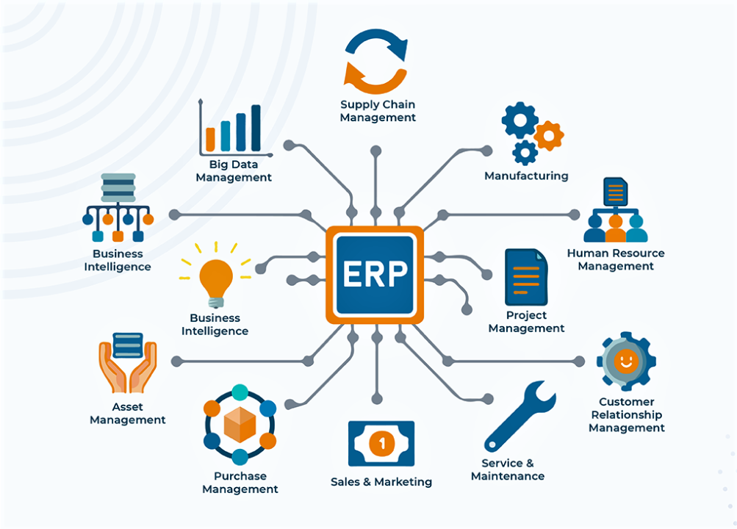

**Advantages of ERP**

* **Improved Efficiency and Productivity:**

ERP systems automate many tasks and streamline processes, leading to increased efficiency and productivity across departments.

* **Enhanced Decision-Making:**

Real-time data access and integrated reporting capabilities enable better and faster decision-making.

* **Better Customer Service:**

ERP systems can improve customer service by providing a single source of truth for customer information and facilitating faster response times.

* **Improved Collaboration:**

ERP systems enable seamless communication and data sharing between different departments, fostering collaboration.

* **Reduced Costs:**

By automating processes and reducing errors, ERP systems can lead to significant cost savings.

* **Data Accuracy and Security:**

ERP systems ensure data accuracy by centralizing data in a single database and providing robust security features**.**

* **Improved Compliance:**

ERP systems can help organizations comply with various regulations by providing tools for managing employee data, tax calculations, and other compliance tasks.

* **Scalability and Flexibility:**

ERP systems can be scaled to meet the needs of a growing business and can be customized to fit specific business processes.

* **Enhanced Visibility:**

ERP systems provide real-time visibility into business operations, allowing managers to monitor performance and make informed decisions.

* **Improved Inventory Management:**

ERP systems can optimize inventory levels, reduce carrying costs, and improve on-time delivery.

**Disadvantages of ERP**

* **High Initial Costs:**

ERP systems can be expensive to purchase, implement, and maintain.

* **Complexity and Implementation Challenges:**

ERP systems can be complex to set up and require significant training and change management.

* **Potential for Disruptions During Implementation:**

Implementing an ERP system can disrupt business processes and require temporary downtime.

* **Resistance to Change:**

Employees may resist changes to their workflows when an ERP system is implemented**.**

* **Customization Risks:**

Customizing an ERP system can increase costs and implementation time, and may lead to challenges in maintaining and upgrading the system.

* **Data Integration Challenges:**

Integrating data from different departments and systems can be a significant challenge.

* **Need for Ongoing Maintenance and Support:**

ERP systems require ongoing maintenance, updates, and support to ensure they continue to function properly.

* **Security Risks:**

ERP systems can be vulnerable to cyberattacks if not properly secured.

**“Step Of ERP Implementation Process”**

The **ERP (Enterprise Resource Planning) implementation process** is a structured approach that organizations follow to integrate ERP software into their business operations. Successful implementation requires careful planning, coordination, and execution. Here’s a step-by-step overview:

**Key Steps in the ERP Implementation Process:**

1. **Project Planning & Assessment**

* Define objectives, scope, and deliverables.
* Assemble the project team (including IT, business stakeholders, and ERP vendor reps).
* Develop a timeline and budget.

1. **Business Process Analysis**

* Analyze and document current workflows.
* Identify pain points, redundancies, or inefficiencies.
* Define future workflows that align with ERP capabilities.

1. **Requirements Definition**

* List technical and functional requirements.
* Prioritize key features (e.g., finance, inventory, HR modules).
* Ensure alignment with regulatory and security standards.

1. **ERP Software Selection**

* Evaluate vendors (e.g., SAP, Oracle, Microsoft Dynamics, Odoo).
* Conduct product demos and request proposals.
* Choose the ERP system that best fits organizational needs.

1. **System Design & Customization**

* Configure modules to meet business needs.
* Customize only where absolutely necessary to reduce complexity.
* Design integrations with existing systems (CRM, eCommerce, etc.).

1. **Data Migration**

* Cleanse existing data (remove duplicates, standardize formats).
* Map old data fields to new ERP structure.
* Migrate data in phases or all at once (big bang), followed by validation.

1. **Testing**

* Perform unit testing, system testing, and user acceptance testing (UAT).
* Fix bugs and refine workflows.
* Ensure all integrations and customizations work as expected.

**8. Training & Change Management**

* Train end-users and administrators.
* Develop user manuals and conduct workshops.
* Address employee concerns and encourage adoption.

1. **Deployment (Go-Live)**

* **Choose deployment strategy:**
  + **Big Bang: All users switch at once.**
  + **Phased: Gradual rollout by department or location.**
* **Monitor closely for issues.**

1. **Post-Go-Live Support & Maintenance**

* Offer continuous user support.
* Monitor performance and address issues quickly.

**Process flow of material management in ERP**

**The Material Management (MM) process flow in ERP—particularly in systems like SAP—focuses on the efficient management of materials (raw materials, components, finished goods) across the supply chain. It integrates procurement, inventory, and warehouse functions to ensure the right material is available at the right time, in the right quantity.**

**Material Management Process Flow in ERP**

1. **Material Master Creation**

* Create a unique master record for each material.
* Contains information like material type, unit of measure, valuation class, etc.
* Serves as the foundation for all MM processes.

1. **Purchase Requisition (PR)**

* Internal department requests a material.
* PR is an internal document—not aa legal offer.
* May be created manually or automatically (based on MRP or stock limits).

**3. Request for Quotation (RFQ)**

* Sent to approved vendors.
* Collects price, delivery time, payment terms.
* Vendors respond with quotations.

**4. Vendor Selection & Purchase Order (PO)**

* Evaluate quotations and select the best vendor.
* Create and send a **Purchase Order** (legally binding).
* Includes quantity, price, delivery date, terms.

**5. Goods Receipt (GR)**

* Material arrives at the warehouse.
* Goods are checked for quantity and quality.
* ERP updates inventory and generates a **Goods Receipt Note**.

**6. Quality Inspection (if applicable)**

* Inspected based on quality parameters.
* Approved goods are moved to **unrestricted stock**.
* Rejected goods go to blocked stock or returned.

**7. Inventory Management**

* ERP updates stock levels in real-time.
* Material is available for production or sales.
* Tracks batch, serial number, location, valuation, etc.

**8. Invoice Verification**

* Vendor sends invoice.
* ERP matches:
  + Purchase Order
  + Goods Receipt
  + Invoice
* Any discrepancies are flagged.

**9. Payment Processing**

* After successful verification, payment is processed.
* Financial accounting (FI) module is updated.

**Simplified Flow Diagram:**

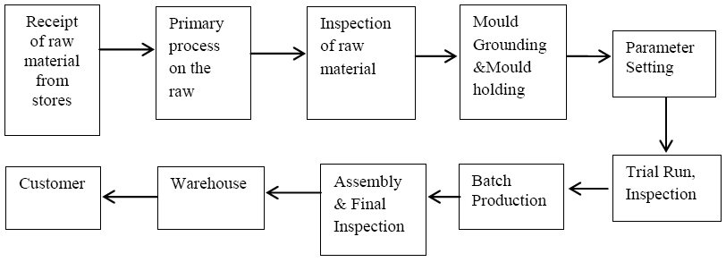

**Key ERP Modules Involved:**

* **MM (Material Management) – Core of the process.**
* **PP (Production Planning) – Links material availability to manufacturing.**
* **FI (Financial Accounting) – Handles payments and invoices.**
* **WM (Warehouse Management) – For detailed stock control.**
* **SD (Sales & Distribution) – For outbound logistics integration.**

**Key Components for setting up Material Management Module**

* **When multiple projects are being managed then assigning of Unique Project Number Schema reduces the ambiguity.**
* **Material Storage Location must be clearly defined and marked.**
* **Inspection, Certifications, Quality Management, Tracked Digitally.**

**The unit of measure and material classifications must be descriptive and accurate to ensure all material can be found quickly and efficiently.**

**Main Element Used To Implementation ERP**

**In ERP implementation, master data, transactions, and reports are three crucial elements that work together to manage an organization's core business processes. Master data provides the foundation for business transactions, and reports aggregate and analyze transaction data to provide insights.**

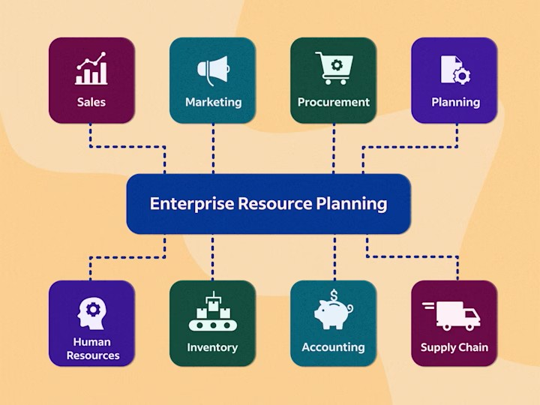

* + 1. **Master Data:**
* **Definition:**

Master data is the core, structured data that defines the organization and its resources. It includes information about customers, products, employees, and other essential entities.

* **Importance:**

Master data serves as the foundation for all business transactions within the ERP system. It ensures consistency and accuracy in data usage across the organization.

* **Examples:**

1. Customer Master
2. Vendor Master
3. Material/Item Master
4. Employee Master
   * 1. **Transaction:**

* **Definition:**

Transactions represent the activities and processes that occur within the organization, such as sales orders, purchase orders, inventory movements, and financial postings.

* **Importance:**

Transactions capture the dynamic data that changes over time, reflecting the organization's real-time business operations. They are the application programs that execute business processes in the system.

* **Examples:**

1. Sales Orders
2. Purchase Orders
3. Payments
4. Goods Receipts
5. Payroll Transactions
   * 1. **Reporting and Analytics:**

* **Definition:**

Reports provide summaries and analyses of data generated by transactions and stored in the ERP system.

* **Importance:**

Reports help stakeholders gain real-time visibility into their critical processes, such as sales, finance, inventory, and production. They enable informed decision-making and streamline business processes.

* **Examples:**

1. Sales Reports
2. Inventory Status Reports
3. Financial Statements
4. Vendor Performance Reports
   * 1. **Configuration/Control Data:**

* **Definition:**

In essence, master data provides the foundation, transactions capture the action, and reports provide the analysis and insights that drive business decisions.

* **Purpose**:

Adapts ERP to specific business needs. Ensures processes align with company policies.

* **Examples**:

1. Tax rules
2. Fiscal year settings
3. Organizational structure

**5.Users and Roles:**

* **Definition:**

People who use the system and their permissions.

* **Purpose**:

Ensure secure access. Assign correct responsibilities in the system.

* **Examples**:

1. Sales Executive
2. Finance Manager
3. Inventory Clerk

**📊 Summary Table:**

| Element | Description | Example |
| --- | --- | --- |
| Master | Core reference data | Customer, Vendor, Product |
| Transaction | Day-to-day business activity data | Sales Orders, Payments, Deliveries |
| Reports | Analytical output from ERP | Sales Report, Profit & Loss, Stock Levels |

**How they work together:**

* Master data provides the baseline information for transactions. For example, when creating a sales order, the system uses customer master data to populate the order details.
* Transactions create new data, updating the ERP system and reflecting the latest business operations.

Reports aggregate and analyze both master and transactional data, providing insights and reports that help decision-making.

**KNOWLEDGE GAIN ACHIEVEMENT FROM PROJECT**

When discussing knowledge gain and achievements from a project, it's helpful to focus on specific skills, insights, and quantifiable results. Highlight how you used your knowledge to achieve project goals, mention specific actions taken, and quantify successes when possible. a well-structured response you can use to describe the knowledge gained and achievements experienced from a project, especially relevant to ERP or any technical/business project.

1. **Technical Knowledge**

* Gained hands-on experience with ERP systems.
* Understood core ERP modules like Finance, Sales, Inventory, and HR.
* Learned how to manage master data, transaction data, and generate reports.
* Gained knowledge of data migration, configuration, and customization.

1. **Business Process Understanding**

* Developed a clear understanding of real-world business workflows.
* Learned how different departments (e.g., procurement, finance, HR) are integrated.
* Understood how ERP improves efficiency, reduces errors, and enhances decision-making.

1. **Teamwork and Communication**

* Collaborated with team members, stakeholders, and users from different departments.
* Learned how to document requirements and present solutions effectively.
* Participated in meetings, status updates, and feedback sessions.

1. **Personal Achievements**

* Successfully completed the ERP project within scope and deadline.
* Improved confidence in handling enterprise software tools.
* Contributed to smoother business operations through improved process mapping or automation.
* Received positive feedback from supervisors or users.